Long Island Project Development Experience

**AgEnergy, through its subsidiary, Clearview Power completed development of 4 Power Projects on Long Island. The following is a summary of the Projects.**

**PPL Brentwood**

**PPL Brentwood-80MW Facility using 2 LM6000’s (natural gas fired)**

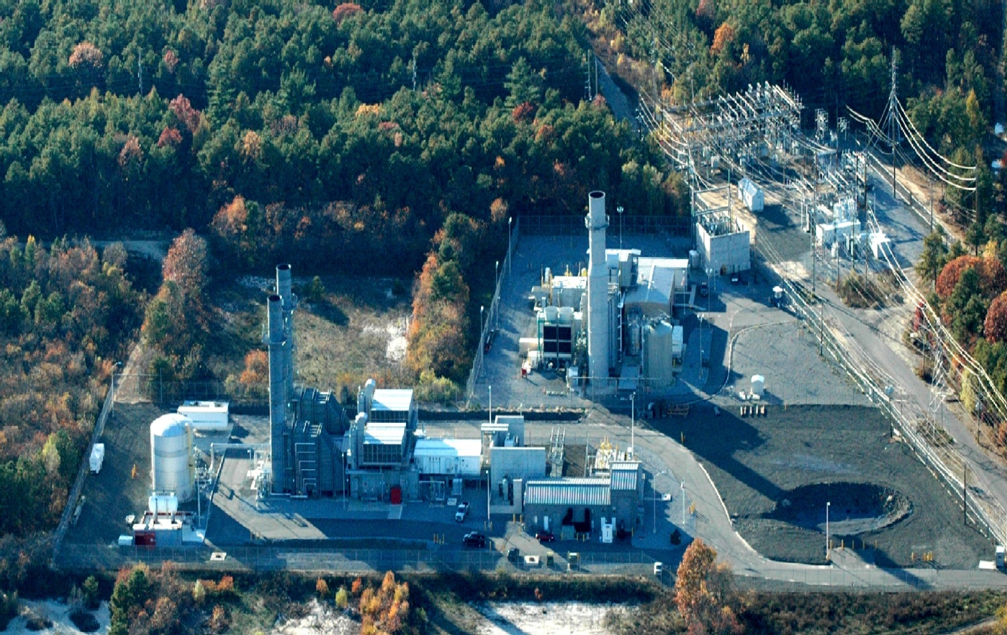

Freeport Electric

**Freeport Electric-Equus II Project-80MW Simple Cycle Peaking Project**

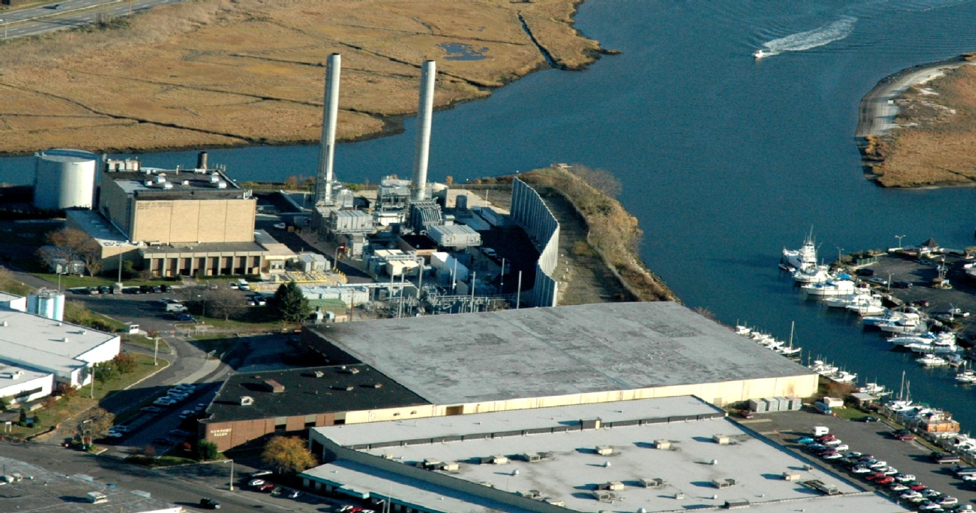

**PPL Shoreham**

**PPL Shoreham-80MW simple cycle liquid fuel peaking facility**

**Located on the property of the Shoreham Nuclear Plant, this Project was the first application/installation and operation of a simple cycle, liquid fuel application of a Selective Catalytic Reduction system.**

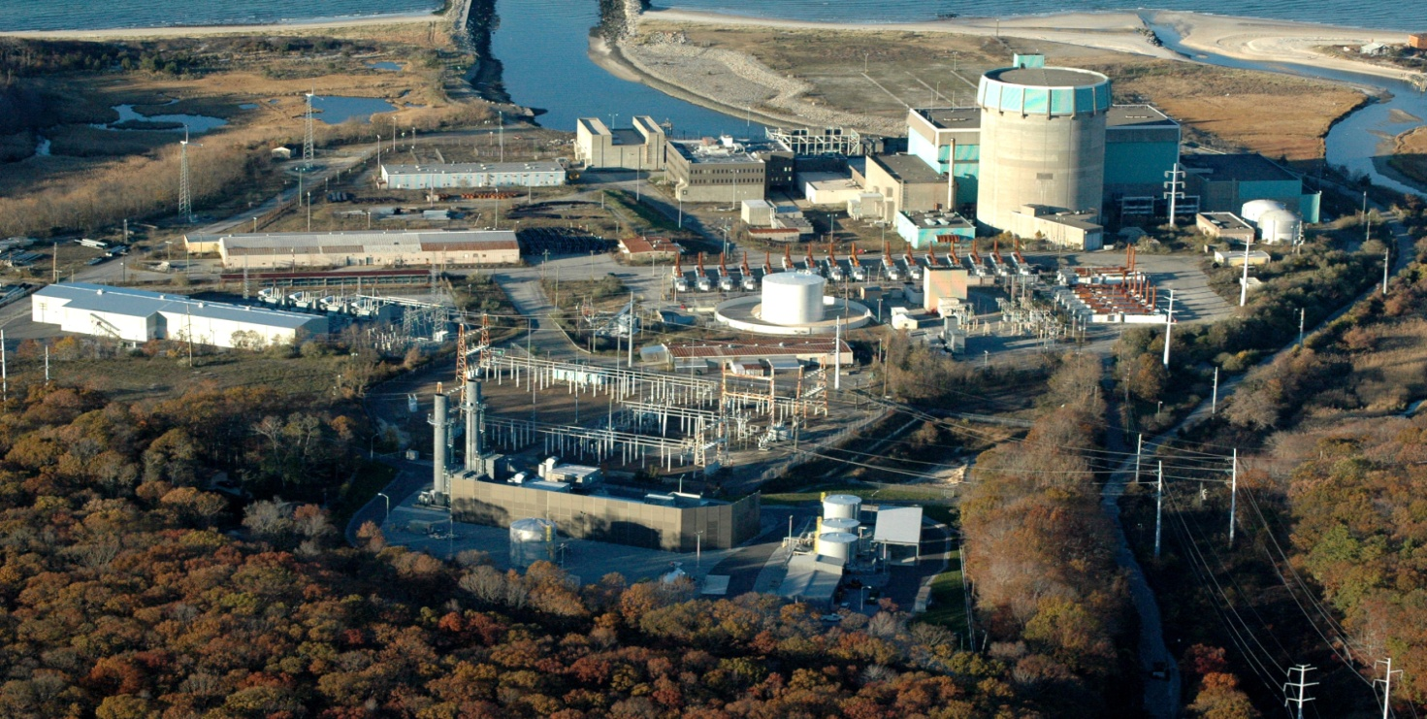

**Pinelawn Power**

**Pinelawn Power-80MW Dual Fuel Fired -combined cycle facility.**

**The Pinelawn Project was very unique for Long Island. The unique features included,**

* **Dual Fuel (Natural Gas and JP 40)**
* **Fully dispatchable across a broad range of output levels**
* **Full supplemental firing capacity**
* **Wet cooling cycle, the last wet cycle permitted in NYS**
* **A once through steam generator (OTSG)**

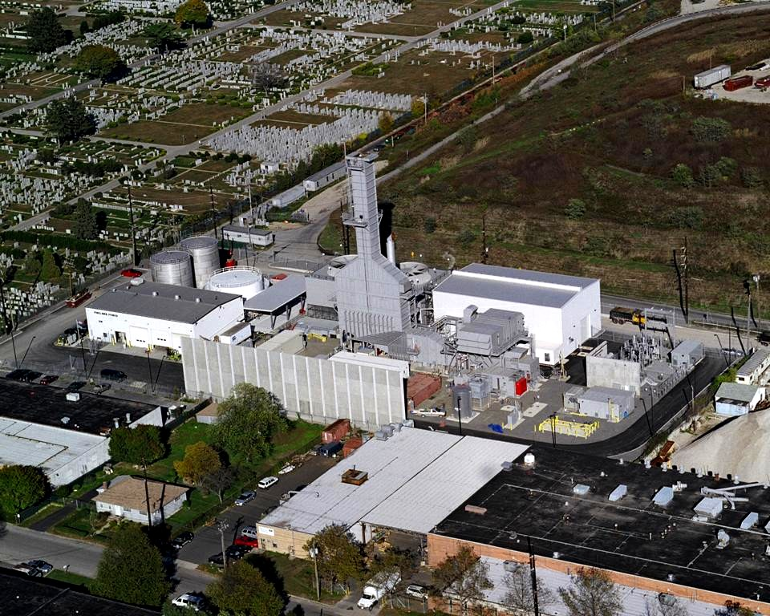

**Brentwood**

**This is a picture of the Edgewood Facility during construction (see pg 1). It is also referred to as the Brentwood Project. The Project consists of two GE LM6000’s with integrated high temperature selective catalytic reduction system for NOX/VOC control. The Project operates on Natural Gas.**

**AgEnergy and it’s subsidiary company, Clearview completed development, financing and construction management of this $120 million project.**

